Aber SailBot
Design Specification

Cubuoyd, Mk I

Specification Written by Jack Morgan (jam30@aber.ac.uk)

Created 10-19-2015

Cubuoyd, Mk I
“BottleBoat” Design, Aber SailBot
Design Created by Jack Morgan (jam30@aber.ac.uk)
This document is an initial design to a robotic boat idea (nicknamed “Cubuoyd”) for the “BottleBoats” project created by the Aber SailBot team. For more information on Aber Sailbot visit our website at http://abersailbot.co.uk/

The core idea of Cubuoyd is to be simple, hydrodynamic, and fail-proof. The trademark design of the boat is the cuboid case which sits in the middle of the boat which is the waterproofed housing for the electronic system. The case is designed to be non-obtrusive with function over style.

Summary and Main Features
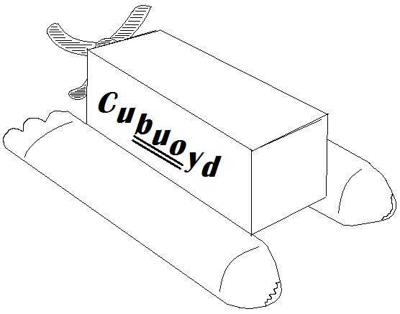 | - Basic cuboid shape ensures the computer system (Arduino etc.) does not take up uneccessary space  - The box will have one or more layers of water-proofing (soft plastic wrapping, hard plastic container etc.)  - The overall design of the boat will remain simple but physically effective

The Box: System Components and Physical Design
<Illustration(s) here> | <Description(s) here>

Logical Design (Software, Programming Considerations)
<Illustration(s) here> | <Description(s) here>

“Water Blades” Design
<Illustration(s) here> | <Description(s) here>

Adhesive Design: How it All Connects
<Illustration(s) here> | <Description(s) here>

Gant Chart
- Design document and team organisation
- Hardware planning: list of all items needed etc. - AND - software planning: pseudocode/visual concepts etc.
- Team review: status of hardware and software progress, sync them up before next step
- Begin hardware building – AND – begin software building
- Team review: status of hardware and software progress, sync them up before next step
- Hardware challenge: test boat durability (water-proofing etc.) WITHOUT system inside (Arduino etc.)
- Software challenge: test software for bugs etc.
- Team review: status of hardware and software progress, sync them up before next step
- First bottle-boat test

